As Shown in the Architecture the Code will be available in Github actions , once the developer pushes the code the code will get validated on the below 3 stages.

1.Sonar Cloud

2.Junit

3.Jfrog

Once the above 3 validation is done , there will be a auto Deployment will start happen .

Below are the Work process in the GitHub actions For the Build, Deploy ,Integration and regression test .

1.Go to the workflow Release Build then click on to the run workflow option select the build option and trigger the build , In case if we need the particular build deploy details , take the build no from the previous history give the build number and deploy .

Please find the attached Screenshot .

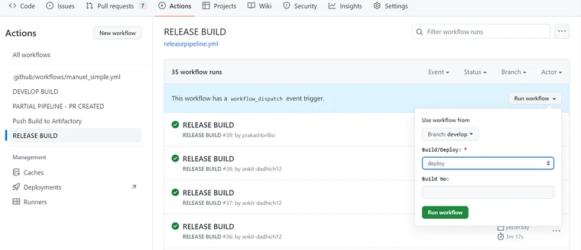

There is no option to remove the build option , please find the attached document.

<https://github.com/orgs/community/discussions/12029>

refer to the attached YAML file for the Release pipeline .